Representative:

Assign Temporary Department Representative

Click “Assign Temporary Department Representative” link from menu then can view current temporary department representative

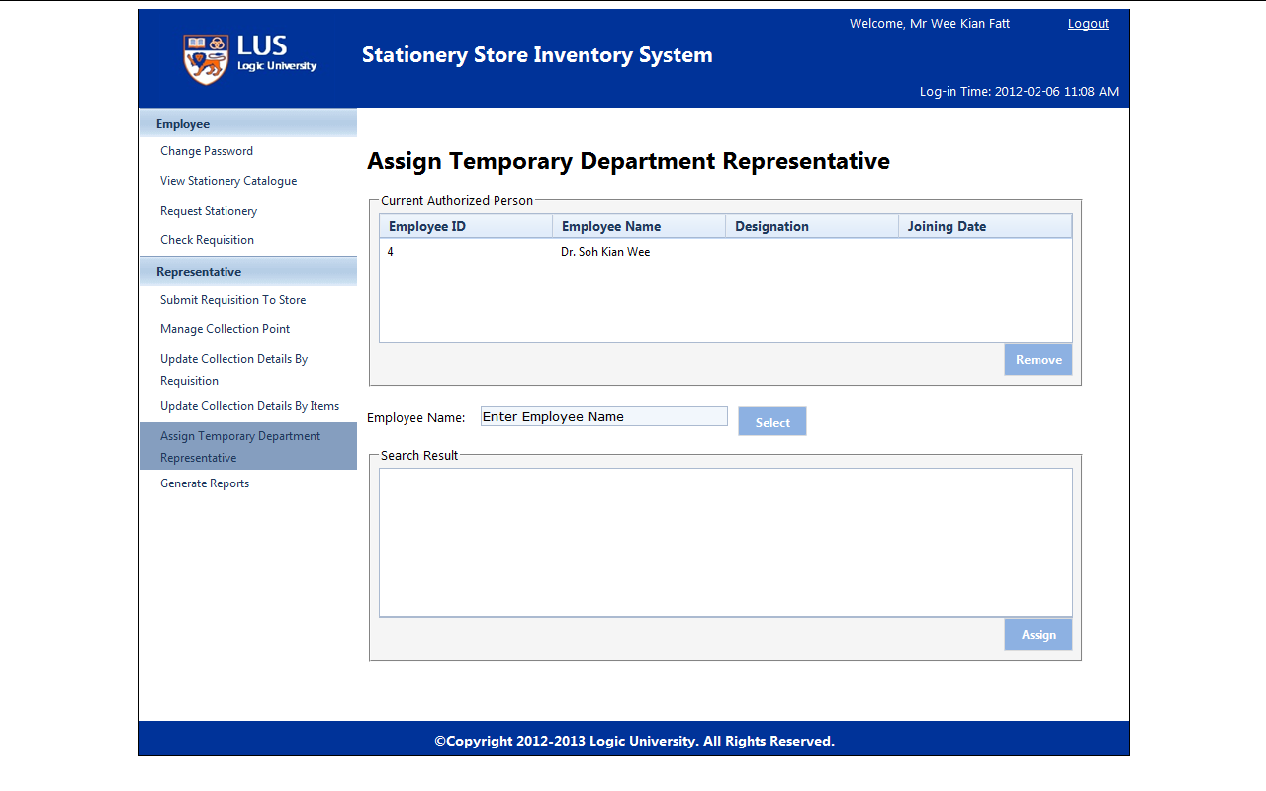

Click “Remove” to remove current temporary representative

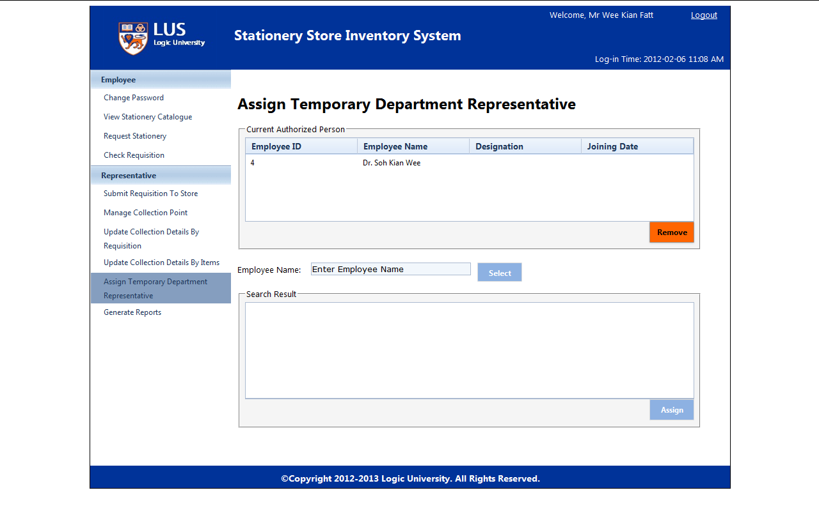

Search employee name and click “Select” to select desire employee

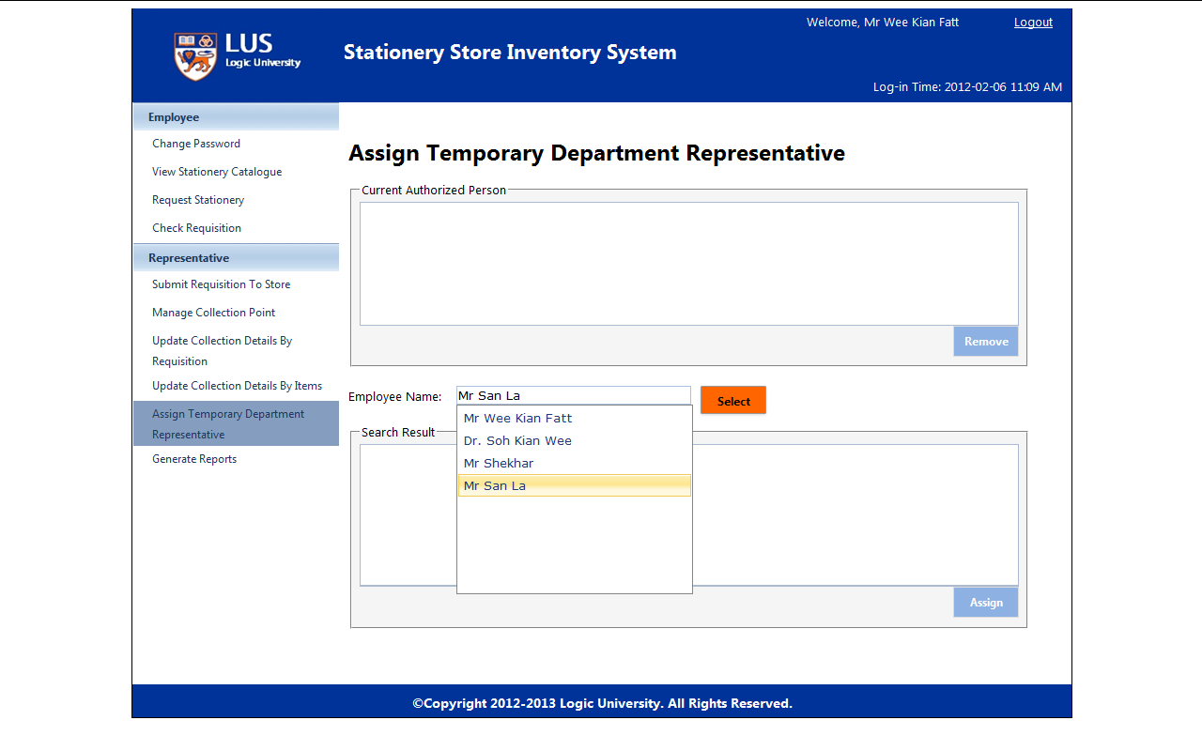

Click “Assign” to assign selected employee to be temporary representative

